**Exercise 1:Configuring a Basic Spring Application**

**File : applicationContext.xml**

<?**xml** version=*"1.0"* encoding=*"UTF-8"*?>

<**beans** xmlns=*"http://www.springframework.org/schema/beans"*

xmlns:xsi=*"http://www.w3.org/2001/XMLSchema-instance"*

xsi:schemaLocation=*"*

*http://www.springframework.org/schema/beans*

*http://www.springframework.org/schema/beans/spring-beans.xsd"*>

<!-- BookRepository Bean -->

<**bean** id=*"bookRepository"* class=*"com.library.repository.BookRepository"*/>

<!-- BookService Bean -->

<**bean** id=*"bookService"* class=*"com.library.service.BookService"*>

<**property** name=*"bookRepository"* ref=*"bookRepository"*/>

</**bean**>

</**beans**>

**File: BookService.java**

package com.library.service;

import com.library.repository.BookRepository;

public class BookService {

private BookRepository bookRepository;

// Setter for Spring to inject dependency

public void setBookRepository(BookRepository bookRepository) {

this.bookRepository = bookRepository;

}

public void addBook(String bookName) {

System.***out***.println("Adding book: " + bookName);

bookRepository.saveBook(bookName);

}

}

**File: BookRepository.java**

package com.library.repository;

public class BookRepository {

public void saveBook(String bookName) {

System.***out***.println("Saving book: " + bookName);

}

}

**File: App.java**

package com.library.LibraryManagement;

import org.springframework.context.ApplicationContext;

import org.springframework.context.support.ClassPathXmlApplicationContext;

import com.library.service.BookService;

public class App {

public static void main(String[] args) {

// Load Spring context

ApplicationContext context = new ClassPathXmlApplicationContext("applicationContext.xml");

// Retrieve the bean

BookService bookService = context.getBean("bookService", BookService.class);

// Use the bean

bookService.addBook("Spring in Action");

}

}

**Output:**

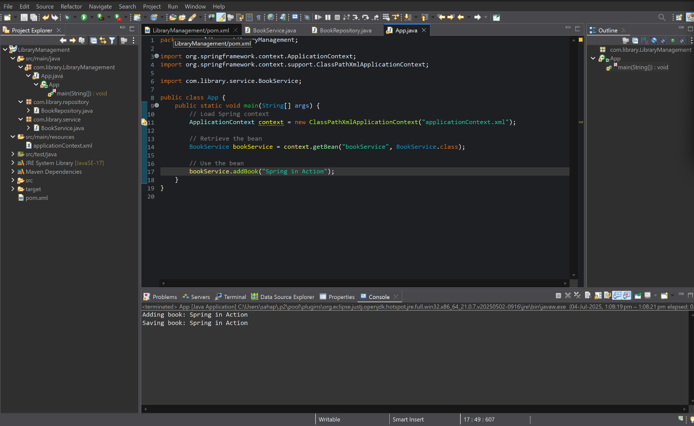

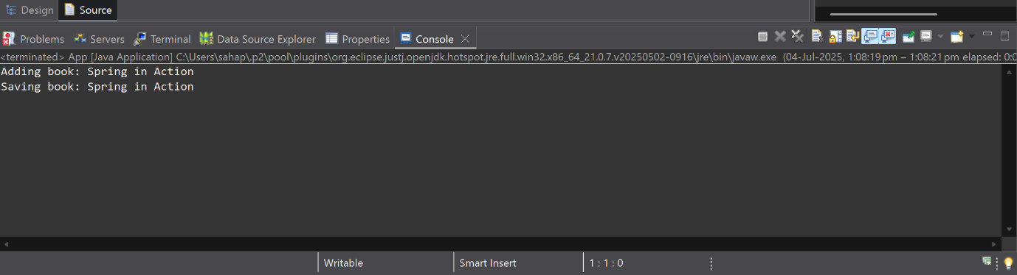

**Exercise 2:Implementing Dependency Injection**

**File:applicationContext.xml**

<?**xml** version=*"1.0"* encoding=*"UTF-8"*?>

<**beans** xmlns=*"http://www.springframework.org/schema/beans"*

xmlns:xsi=*"http://www.w3.org/2001/XMLSchema-instance"*

xsi:schemaLocation=*"*

*http://www.springframework.org/schema/beans*

*http://www.springframework.org/schema/beans/spring-beans.xsd"*>

<!-- Repository Bean -->

<**bean** id=*"bookRepository"* class=*"com.library.repository.BookRepository"*/>

<!-- Service Bean with DI -->

<**bean** id=*"bookService"* class=*"com.library.service.BookService"*>

<**property** name=*"bookRepository"* ref=*"bookRepository"*/>

</**bean**>

</**beans**>

**File: BookService.java**

package com.library.service;

import com.library.repository.BookRepository;

public class BookService {

private BookRepository bookRepository;

// Setter for Dependency Injection

public void setBookRepository(BookRepository bookRepository) {

this.bookRepository = bookRepository;

}

public void addBook(String bookName) {

System.***out***.println("Adding book: " + bookName);

bookRepository.saveBook(bookName);

}

}

**Output:**

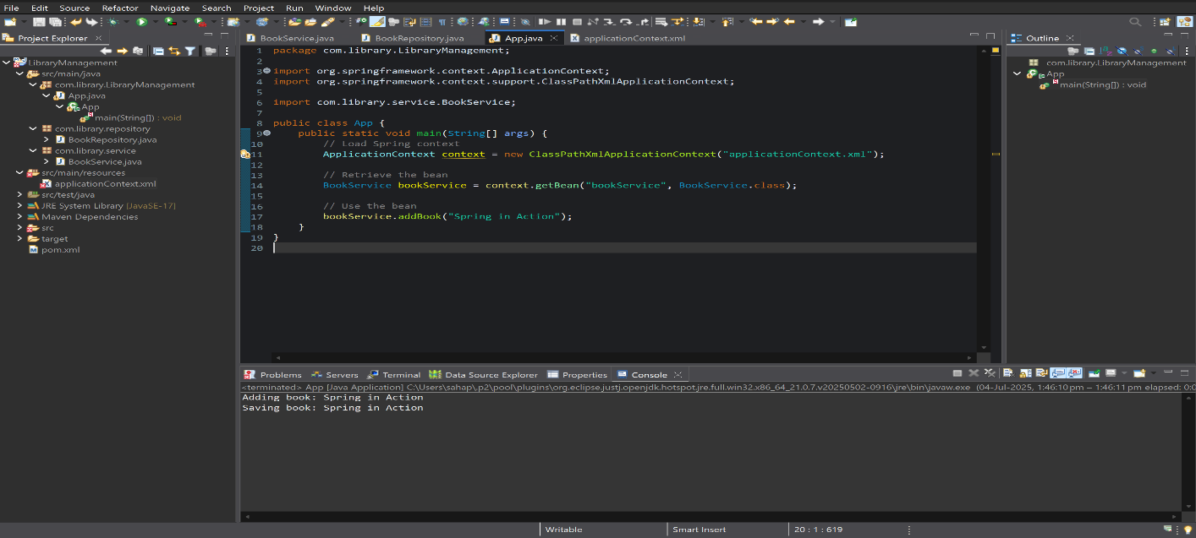

**Exercise 4: Creating and Configuring a Maven Project**

**File : LibraryManagement/pom.xml**

<?xml version="1.0" encoding="UTF-8"?>

<project xmlns="http://maven.apache.org/POM/4.0.0" xmlns:xsi="http://www.w3.org/2001/XMLSchema-instance"

xsi:schemaLocation="http://maven.apache.org/POM/4.0.0 http://maven.apache.org/xsd/maven-4.0.0.xsd">

<modelVersion>4.0.0</modelVersion>

<groupId>com.library</groupId>

<artifactId>LibraryManagement</artifactId>

<version>0.0.1-SNAPSHOT</version>

<name>LibraryManagement</name>

<!-- FIXME change it to the project's website -->

<url>http://www.example.com</url>

<properties>

<project.build.sourceEncoding>UTF-8</project.build.sourceEncoding>

<maven.compiler.release>17</maven.compiler.release>

</properties>

<dependencyManagement>

<dependencies>

<dependency>

<groupId>org.junit</groupId>

<artifactId>junit-bom</artifactId>

<version>5.11.0</version>

<type>pom</type>

<scope>import</scope>

</dependency>

</dependencies>

</dependencyManagement>

<dependencies>

<dependency>

<groupId>org.junit.jupiter</groupId>

<artifactId>junit-jupiter-api</artifactId>

<scope>test</scope>

</dependency>

<!-- Spring Core and Context -->

<dependency>

<groupId>org.springframework</groupId>

<artifactId>spring-context</artifactId>

<version>5.3.36</version>

</dependency>

<!-- Spring AOP -->

<dependency>

<groupId>org.springframework</groupId>

<artifactId>spring-aop</artifactId>

<version>5.3.36</version>

</dependency>

<!-- Spring Web MVC -->

<dependency>

<groupId>org.springframework</groupId>

<artifactId>spring-webmvc</artifactId>

<version>5.3.36</version>

</dependency>

<!-- Optionally: parameterized tests support -->

<dependency>

<groupId>org.junit.jupiter</groupId>

<artifactId>junit-jupiter-params</artifactId>

<scope>test</scope>

</dependency>

</dependencies>

<build>

<pluginManagement><!-- lock down plugins versions to avoid using Maven defaults (may be moved to parent pom) -->

<plugins>

<!-- clean lifecycle, see https://maven.apache.org/ref/current/maven-core/lifecycles.html#clean_Lifecycle -->

<plugin>

<artifactId>maven-clean-plugin</artifactId>

<version>3.4.0</version>

</plugin>

<!-- default lifecycle, jar packaging: see https://maven.apache.org/ref/current/maven-core/default-bindings.html#Plugin_bindings_for_jar_packaging -->

<plugin>

<artifactId>maven-resources-plugin</artifactId>

<version>3.3.1</version>

</plugin>

<plugin>

<artifactId>maven-compiler-plugin</artifactId>

<version>3.13.0</version>

<configuration>

<source>1.8</source>

<target>1.8</target>

</configuration>

</plugin>

<plugin>

<artifactId>maven-surefire-plugin</artifactId>

<version>3.3.0</version>

</plugin>

<plugin>

<artifactId>maven-jar-plugin</artifactId>

<version>3.4.2</version>

</plugin>

<plugin>

<artifactId>maven-install-plugin</artifactId>

<version>3.1.2</version>

</plugin>

<plugin>

<artifactId>maven-deploy-plugin</artifactId>

<version>3.1.2</version>

</plugin>

<!-- site lifecycle, see https://maven.apache.org/ref/current/maven-core/lifecycles.html#site_Lifecycle -->

<plugin>

<artifactId>maven-site-plugin</artifactId>

<version>3.12.1</version>

</plugin>

<plugin>

<artifactId>maven-project-info-reports-plugin</artifactId>

<version>3.6.1</version>

</plugin>

</plugins>

</pluginManagement>

</build>

</project>

**OUTPUT:**

